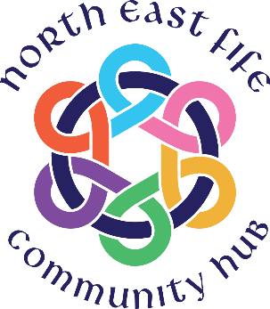

North East Fife Community Hub
Hub Assistant

The North East Fife Community Hub (NEFCH) is based at the St David’s Centre in St Andrews. Here we run our welcoming Community Café and provide a centre for community services and activities. We have a wide range of customers, many of whom are vulnerable members of our community.

We are currently seeking to recruit a Hub Assistant to support the Hub Team. This is a Saturday job, hours of work are 10am to 3pm and further hours may be available. The role will mainly involve working within the café and takeaway.

The role holder will be required to work each Saturday, 5 hours, hourly pay rate £10 - £10.50 dependent on experience.
For more information, further particulars and an application form, please contact David Anderson, Project Coordinator email: david@nefcommunityhub.org or phone 0774 762 5934.
Completed applications to be returned to david@nefcommunityhub.org or by post to St David’s Centre, 23 Albany Park, St Andrews, KY16 8BP.
Closing Date: 23 September 2022
Interviews: 1 October 2022

